Name: ________________________________________ Period: ______

2025-2026 Physics (Regular) Midterm Exam

LaSalle College High School Mr. Werman
Time: 90 Minutes December 2025

Gentlemen,

The exam consists of two parts: Multiple Choice (50%) and Free Response (50%). The Multiple-Choice section has 15 “Conceptual” questions (2 points each) and 10 “Calculation” questions (3 points each). Your answers are to be recorded on the Scantron sheet provided. You may use the space provided for written work, but no partial credit will be rewarded for the multiple-choice questions. The Free Response portion consists of 3 questions worth 20 points for each problem. Take your time while working on the exam and be sure to check your work. For pacing, you should allot about 45 minutes for each part of the exam. Good luck!

General Directions:
1. Place your name and class period on all materials.
2. Show ALL work for free response questions in the space provided or on scrap paper
3. Read the directions carefully and pace yourself appropriately.
4. You may detach the formula sheet from this packet
5. Staple any work on scrap paper to your test and label with the appropriate problem number.

Student Honor Code
A student’s acceptance of enrollment in La Salle College High School and continuation of enrollment in La Salle are contingent upon the student’s acceptance of and adherence to the principles of this Student Honor Code.

RESPONSIBILITIES OF STUDENTS:
- To complete all academic work honestly and independently.
- To refrain from revealing any information regarding the contents of a test, directly or indirectly, to any other student who may subsequently take the same test.
- To refrain from unethical use of computers and/or cellphones.
- To refrain from personal dishonesty as more fully defined in this Honor Code.

Name:__________________________________________________ Period: ______

Multiple Choice I (Conceptual): Mark the letter of the best answer on the Scantron sheet. (2 points each)

1. The distance traveled by an object is always _____________________________ its displacement.
a) Greater than or equal to
b) Less than or equal to
c) Greater than
d) Less than

2. The slope at any point along the line of a position vs time graph represents what quantity?
a) acceleration c) elapsed time
b) displacement d) velocity
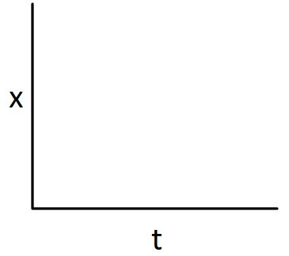



3. Which of the following Position vs Time graphs would best describe a car moving in the negative direction and speeding up?

a) b) c) d)

4. Which scenario describes the greatest amount of displacement?
a) A cyclist travels 25 km west.
b) A racecar completes 15 laps around a 2 km long track.
c) A boat sails 20 km east
d) A car drives 10 km east then turns around and drives another 20 km west.

5. An object moving in the +x direction experiences an acceleration of -2.0 m/s². This means the object
a) travels 2.0 m in every second.
b) is traveling at 2.0 m/s.
c) is decreasing its velocity by 2.0 m/s every second.
d) is increasing its velocity by 2.0 m/s every second.

6. When a car’s velocity is negative and its acceleration is negative, what is happening to the car’s motion?
a) the car slows down
b) the car speeds up
c) the car travels at constant speed
d) the car remains at rest

7. When a ball is thrown straight up and with no air resistance, the acceleration at its highest point
a) is upward.
b) reverses from upward to downward.
c) is downward.
d) is zero.

8. Jimmy and Ryan dive from a cliff overhang into a lake below. Jimmy simply drops straight down from the edge. Ryan takes a running start and jumps out horizontally with an initial velocity of 5 m/s. When they reach the lake below…
a) they will be the same distance away from the cliff.
b) the speed of Jimmy is greater than that of Ryan.
c) they will both have the same speed.
d) they will have been in the air for the same amount of time.

9. The impulse experienced by an object is the same as the object’s change in:
a) velocity c) momentum
b) acceleration d) mass

10. A constant unbalanced force acts on an object. Describe the motion of the object.
a) constant acceleration
b) constant speed
c) constant velocity
d) increasing acceleration

11. A player catches a ball. Consider the impact force of the ball against the player's glove. What is the 3rd Law force pair?
a) The muscular effort in the player's arms
b) The force the glove exerts on the ball
c) Friction of the ground against the player's shoes
d) The player's grip on the glove

12. In which of the following cases would an object have the greatest momentum?
a) A 2 kg object moving at 1 m/s
b) A 5 kg object moving at 0.5 m/s
c) A 3 kg object moving at 2 m/s
d) A 1 kg object moving at 4 m/s

13. Which of the following scenarios BEST describes an object that is accelerating?
a) A bicyclist coasting on a flat road.
b) A bicyclist slowing down as it approaches an intersection.
c) A bicyclist coasting on a flat road after traveling down a large hill.
d) A bicyclist pedaling up a hill to maintain its speed.

14. A car is driving East when the driver removes his foot from the gas pedal and applies the brakes to bring the car to a stop. Which of the following would represent the free‐body diagram of a car during the braking period?
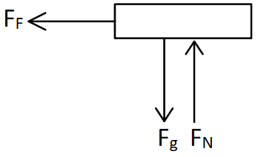
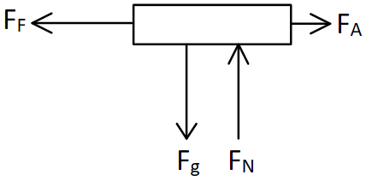
a) c)

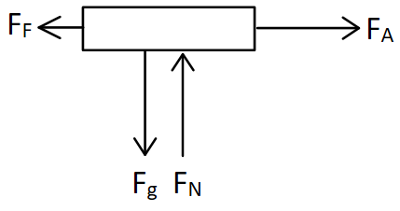
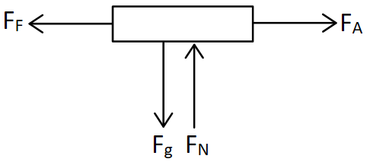
b) d)

15. The normal force on an object always acts in which direction?
a) opposite to gravity
b) perpendicular to the surface
c) upwards
d) parallel to the surface

Multiple Choice II (Calculations): Mark the letter of the best answer on the Scantron sheet. (3 points each)
16. Convert 34 $\frac{kg*m^{3}}{hr} to \frac{lb*ft^{3}}{min}$ (Note: 1 lb = 0.45 kg; 1 m = 3.28 ft)
a) 44.4 $\frac{lb*ft^{3}}{min}$ c) 159,970 $\frac{lb*ft^{3}}{min}$
b) 4.1 $\frac{lb*ft^{3}}{min}$ d) 1.3 $\frac{lb*ft^{3}}{min}$

17. A train starts 100 miles East of Philadelphia traveling West at an average speed of 65 mph. How long is the train ride if the destination is 230 miles West of Philadelphia?
a) 3.54 hours c) 0.20 hours
b) 2 hours d) 5.08 hours

18. A 3000 kg car traveling 15 m/s East collides head-on with a 1000 kg car heading at the same speed West. What is the momentum of the two-car system before the collision?
a) 30,000 kg*m/s
b) 60,000 kg*m/s
c) 45,000 kg*m/s
d) 15,000 kg*m/s

19. A car with a mass of 1200 kg is traveling at 20 m/s when it strikes a 75 kg bicyclist traveling in the same direction at 12 m/s. After the collision, the car is traveling at 18 m/s. How fast is the bicyclist now going?
a) 20 m/s
b) 28 m/s
c) 36.9 m/s
d) 44 m/s

20. A 15.0 kg medicine ball is thrown with a velocity of 5 m/s to a 65 kg figure skater who is at rest on the ice. The skater catches the ball and subsequently slides with the ball across the ice. What is the velocity of the skater after catching the medicine ball?
a) 1.75 m/s
b) 0.94 m/s
c) 1.15 m/s
d) 2.34 m/s

21. A tennisball thrown upward from the ground passes an observer 8 m above with a speed of 12 m/s. What was the speed of the ball when it was released from the ground?
a) 9.8 m/s c) 17.3 m/s
b) 13 m/s d) 96 m/s

22. A ball thrown horizontally at 20 m/s from the roof of a building lands 48 m from the base of the building. How high is the building?
a) 28.2 m c) 0.85 m
b) 11.8 m d) 19.8 m

23. An egg with a mass of 0.062 kg is thrown to the right with a velocity of 31 m/s towards a sheet being held by two class volunteers. The egg is brought to rest by a constant 2.65 N force to the left. How long did it take for the sheet to stop the egg?
a) 0.725 s c) 0.085 s
b) 1.92 s d) 0.941 s

24. A falling bungee jumper with a mass of 75 kg begins to slow with an acceleration of 4 m/s² as the bungee cord stretches. What is the force in the cord? (Ignore air resistance)
a) 1035 N c) 735 N
b) 300 N d) 375 N

25. A 130 N box accelerates across a carpeted floor at 2 m/s² when pushed with a horizontal applied force of 60 N. How much friction acts on the box?
a) 130 N c) 26.5 N
b) 33.5 N d) 86.5 N

Name:__________________________________________________ Period: ______

FREE RESPONSE

SHOW ALL WORK to receive full credit. Write your answer on the line provided and be sure to include proper UNITS.

1. A small fan-powered lab cart (1.5 kg) accelerates from rest on a level surface for 3 seconds. The fan pushes horizontally with a constant force of 5 N and the coefficient of friction between the cart and the surface is 0.2.
a) Draw the FBD of the fan cart
b) Sketch the Position vs Time and Velocity vs Time graphs for the cart’s motion.
c) How far will the cart travel in this time period? _______________

FBD

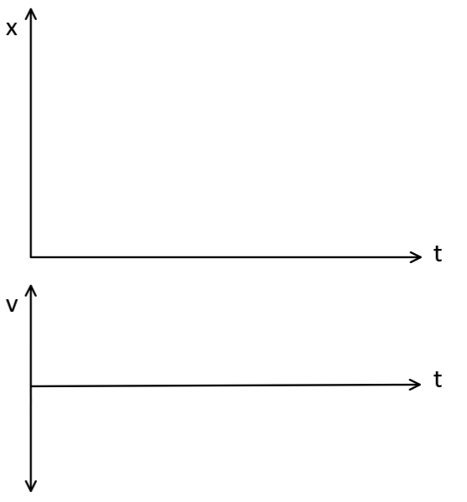
2. Cart A (3 kg) accelerates from rest and reaches a speed of 3 m/s just before colliding with Cart B (1.2 kg) which starts at rest. After the collision, Cart A continues moving at constant speed of 1 m/s, while Cart B gains velocity from the collision and moves at constant speed towards the edge of the table. Cart B leaves the table horizontally and falls to the ground 1.4 m below. (15 Points)

a) How far (horizontally) from the base of the table will Cart B land? ____________
b) Sketch the Position vs Time and Velocity vs Time graphs for each Cart while they are on the table before and after they collide. The dotted line represents the time of the collision. (LABEL THE CARTS)



3. A 0.04 kg Estes model rocket is launched on Meehan field. The rocket motor is rated with an impulse of 2.5 N-s and fires for 0.7 s during the thrust phase of the flight. After the engine fires, the rocket continues in a coast phase to apogee. Assume a constant drag force of 0.2 N during the full ascent and ignore any changes in mass due to the engine firing. (15 Points)

a) Draw the FBDs of the rocket during the thrust and coast phases of the launch.
b) Calculate the maximum altitude of the flight? _______________
c) Sketch the Position vs Time and Velocity vs Time graphs for the rocket during its full ascent to apogee (peak).
Thrust FBD Coast FBD



